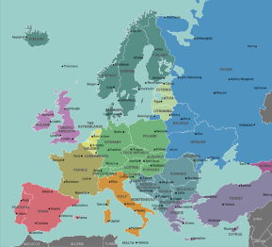
Topic
The UK and Europe

Class Book
Charlie and the Chocolate Factory
by Roald Dahl

Values
Thankfulness & Trust
St Lawrence CE Primary School
Year 4 Curriculum Overview
Terms 1 and 2 2026-2027
Science
- States of Matter
- Sound
PE
- Invasion Games
- Athletics
- Dance
- Rugby
Computing
- The Internet
- Audio Editing
RE
- How do Jews in England celebrate festivals?
- What do Muslims believe about God?
Geography
The UK and Europe —
Locating countries and cities, recognising human and physical geographical features.
French
- Animals
Art/DT
- Collage
- Textiles
Music
- Clarinet lessons
PSHE
- Me and my Relationships
- Valuing Difference
English
Based on the book The Whale by Ethan and Vita Murrow, we will be learning to write setting narratives and newspaper reports.
Maths
- Place Value
- Addition and Subtraction
- Multiplication and Division
- Finding Area

